First larvae mass (N0) at each pond. 2011, 2012, 2016 are all good. 2017 started too late for about 50% of ponds. Don’t use some of those for N0.

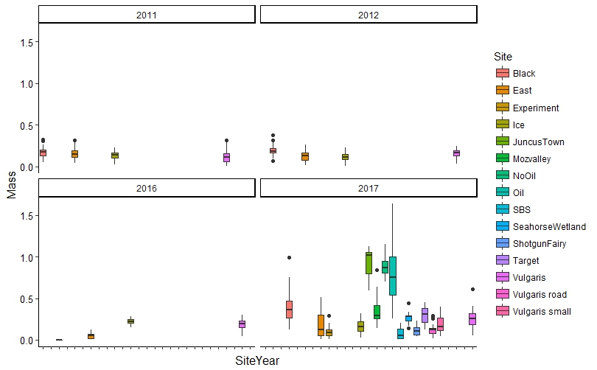

Avg Mass vs. variance for larvae across all ponds (including all dates)

